SQL Views:

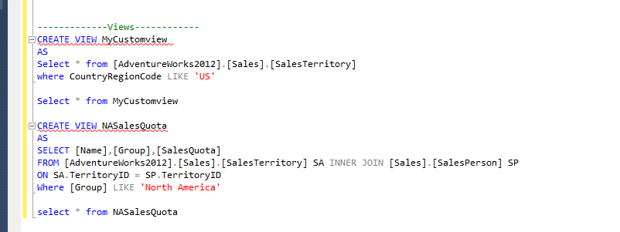

Also able to create from Template explorer

Triggers :

[TABLE Level]

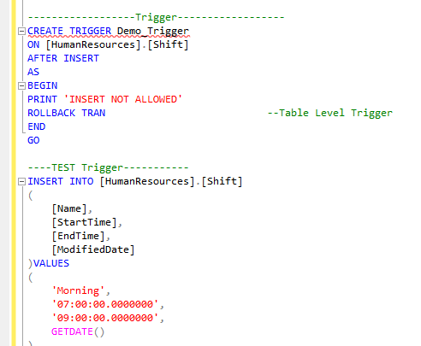

[DATABASE Level]

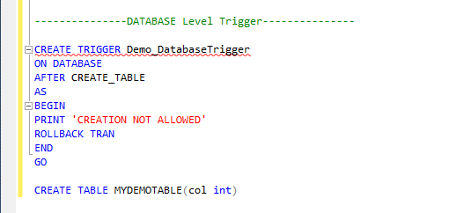

COMPUTED COLUMNS:

Firstname + Lastname = Fullname

We can apply the above formula for computing the column

Transaction :

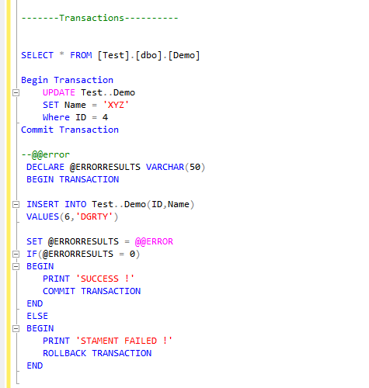

Grouping Sets and Common Table Expression:

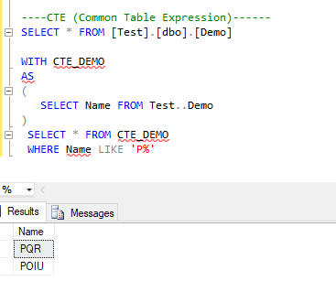

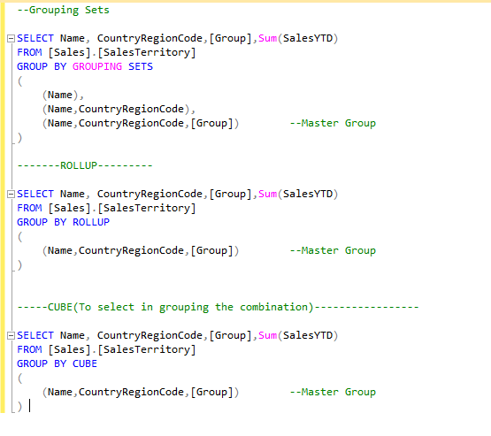

Ranking Functions:

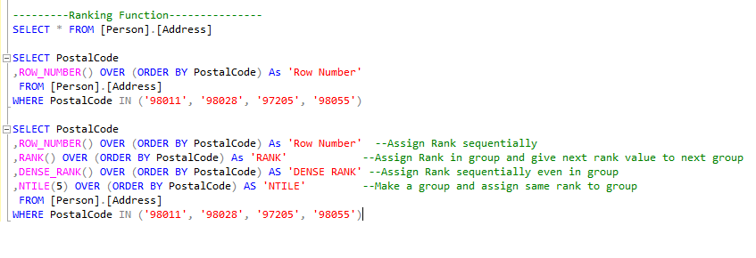

XML DATA :

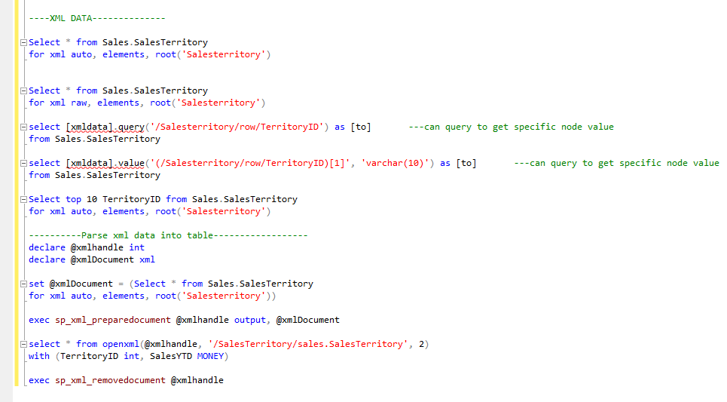

PIVOT and Dynamic Queries :

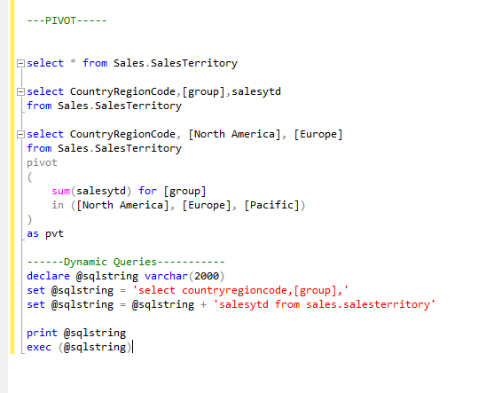

Filestream :

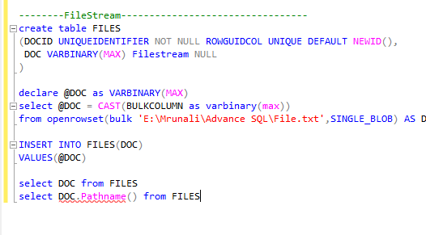

Free Text Search

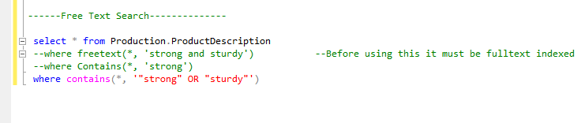

Geometry and Geography data:

